Task – 1 : Git Workflow for Shopping Project

Repository
Git Repository Link: https://github.com/mohit-14-02/Shopping-Project.git

Commits
The following screenshots show the full commit history of the Shopping Project repository.

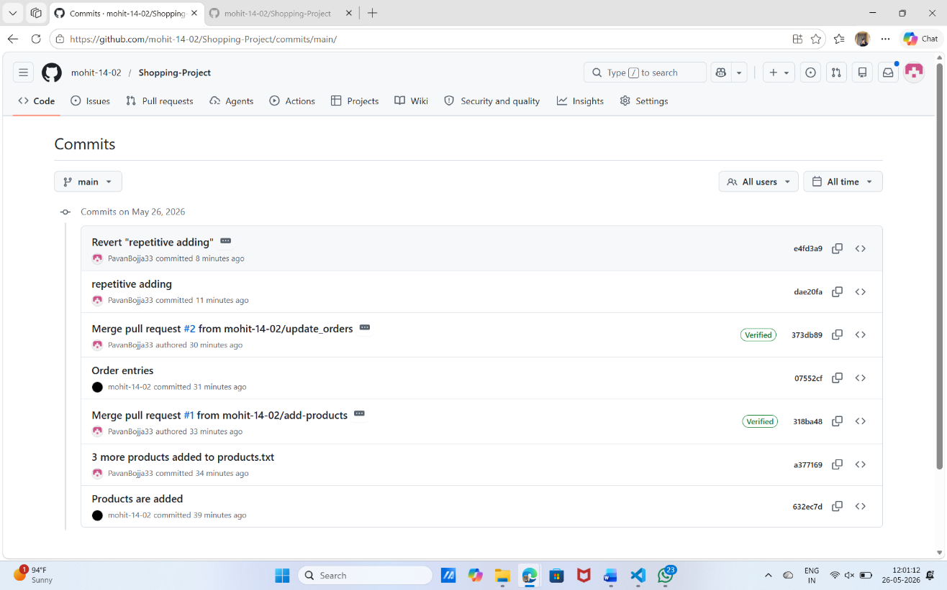

Developer 1 – Commit Log Screenshots
Developer 1 – R. Sai Mohit Kumar (Roll No: 23B81A05AX)

Log Screenshot 1
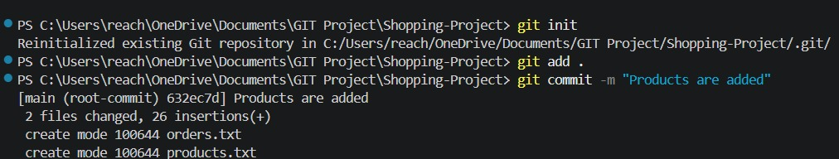

Log Screenshot 2
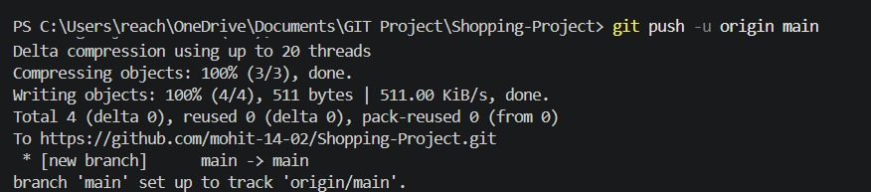

Log Screenshot 3
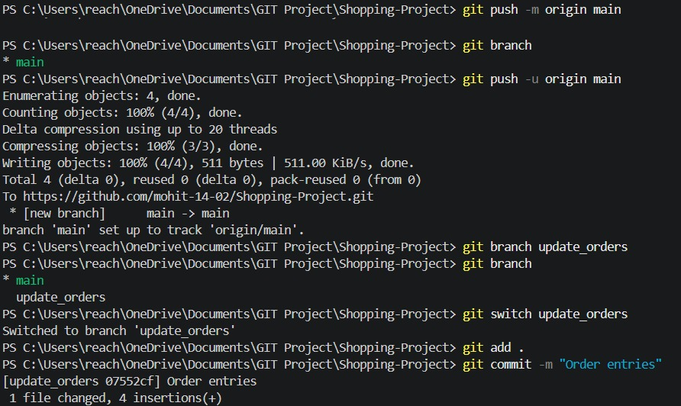

Log Screenshot 4
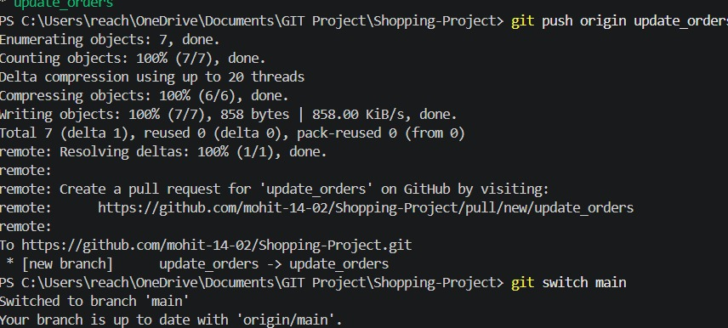

Developer 2 – Commit Log Screenshots
Developer 2 – B. Pavan Kumar Goud (Roll No: 23B81A05AH)

Log Screenshot 1
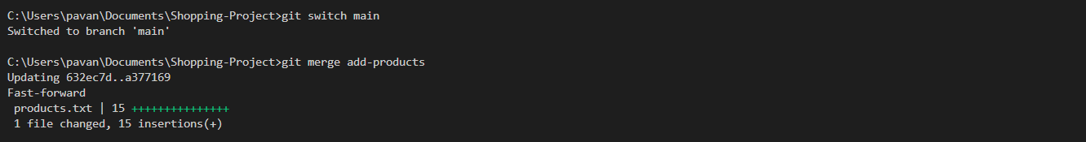

Log Screenshot 2
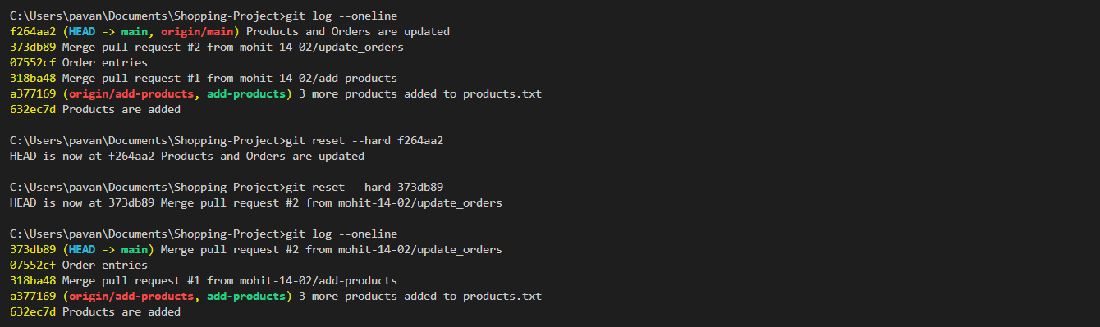

Log Screenshot 3
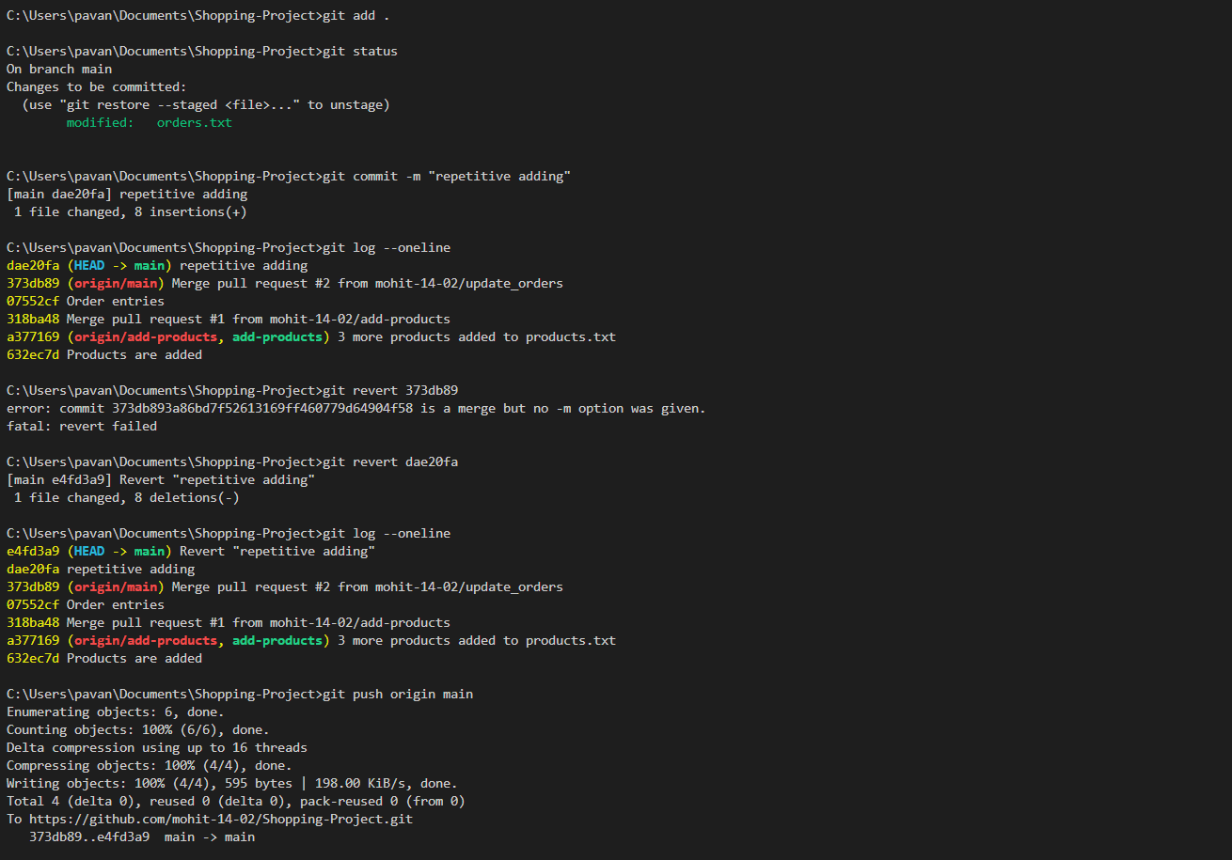

Log Screenshot 4
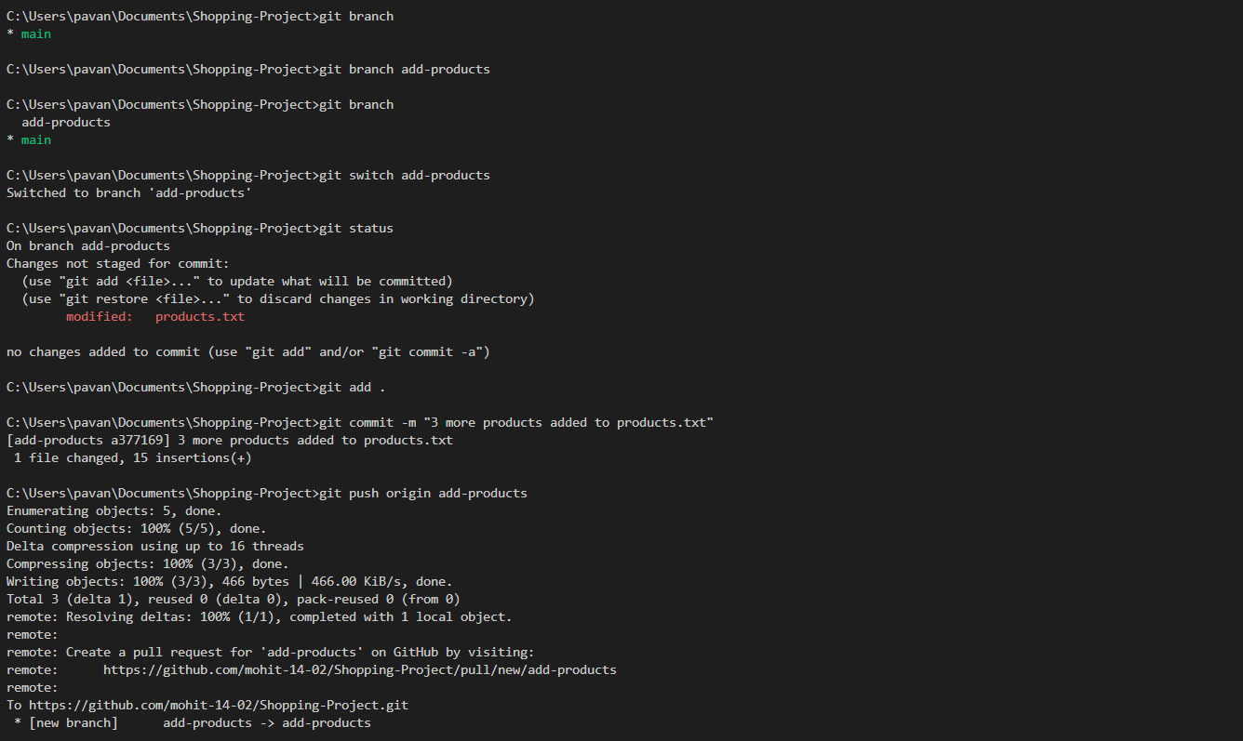

Roles :

Developer 1: R. Sai Mohit Kumar – Roll No: 23B81A05AX
Developer 2: B. Pavan Kumar Goud – Roll No: 23B81A05AH

